Talking Leavers - Social media posts 2020

01 | The official Leavers’ celebration period this year is from Monday 23 November to Thursday 26 November.  For more information, visit the official WA Leavers website. | 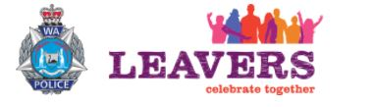 | https://leaverswa.com.au
02 | Concerned about the safety of your child during Leavers this November?  Register for a free information session on 20 September to help you keep your child safer. |  | https://www.sdera.wa.edu.au/leavers
03 | WA Police and partners are holding a free information session on 20 September for parents about Leavers’ celebrations.  Visit the website for more information.  The official Leavers’ period is Monday 23 November to Thursday 26 November. |  | https://www.sdera.wa.edu.au/leavers/
04 | The South West will play host for school Leavers’ celebrations this November.  Register for a free parents’ information session on 20 September to hear about what’s happening at the event. | 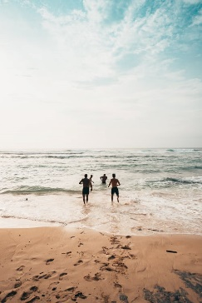 | https://www.sdera.wa.edu.au/leavers/
05 | It’s important for parents to start talking with their child about safety at Leavers’ celebrations in November.  Register for a free parents’ information session on 20 September to hear ways you can speak about alcohol and other drugs. |  | https://www.sdera.wa.edu.au/leavers/

