Talking Leavers - Social media posts

01 | The official Leavers’ celebration period this year is from Monday 18 November to Thursday 21 November.  For more information, visit the official WA Leavers website. | 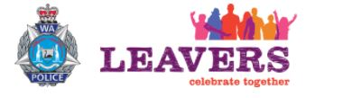 | https://leaverswa.com.au
02 | Concerned about the safety of your child during Leavers this November?  Register for a free information session on 13 October to help you keep your child safer. |  | https://www.sdera.wa.edu.au/parents/school-leavers/
03 | WA Police and partners are holding a free information session on 13 October for parents about Leavers’ celebrations.  Visit the website for more information.  The official Leavers’ period is Monday 18 November to Thursday 21 November. |  | https://www.sdera.wa.edu.au/parents/school-leavers/
04 | The South West will play host for school Leavers’ celebrations this November.  Register for a free parents’ information session on 13 October to hear about what’s happening at the event. | 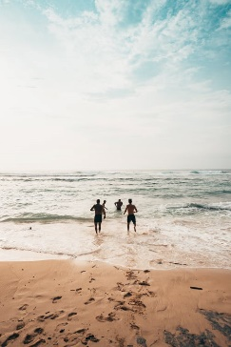 | https://www.sdera.wa.edu.au/parents/school-leavers/
05 | It’s important for parents to start talking with their child about safety at Leavers’ celebrations in November.  Register for a free parents’ information session on 13 October to hear ways you can speak about alcohol and other drugs. |  | https://www.sdera.wa.edu.au/parents/school-leavers/

